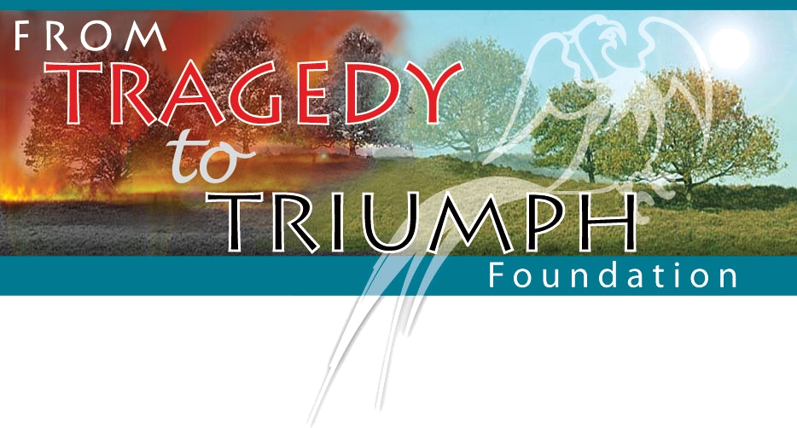

For Burn Survivor’s
For Burn Survivors
Saturday, June 8, 2024

Old Oak Country Club
14200 Parker Rd

Homer Glen, IL. 60491

(708) 301-3344

Schedule of Events: 10:45 to 12:15- Registration and Patio lunch

12:30pm- 4 Person Scramble, Shotgun Start,
Practice range balls before event

(104 golfers maximum)
6:00 – Buffet Dinner (CASH BAR)

$150.00 Golfer: Includes: golf, cart, range balls, lunch, 2 drink tickets and dinner

PLEASE MAIL THIS FORM WITH PAYMENT BY May 1, 2024 ========================================================
Tragedy to Triumph Foundation Golf Outing
Registration form (pleases type or print legible)
My Name: |  | Golfer 1:
Address: |  | Golfer 2:
City, State, Zip: |  | Golfer 3:
Phone: |  | Golfer 4:
E-mail:

 | Please assign me to a foursome |  | I am golfing with above golfers

Payment:
 | Total Golfers @ $150.00 | $
 | Cash Donation | $
 | Sponsor a Hole @ $200.00 (Includes sign) and Name on FTTTF’s web-site for 6 months | $
 | Sponsor a Beer Cart or Lunch @ $500.00 (Sign & name on our website for 6 months) | $
 |  | $
 | Total payment enclosed: | $

CHECKS PAYABLE TO: Tragedy to Triumph Foundation
RETURN REGISTRATION AND PAYMENT TO: Dave Schury 1421 Notting Hill Dr. Lemont, Il. 60439
Cell (630) 408-2775 • E-mail: dave@ftttf.org
Web-Site... www.ftttf.org

